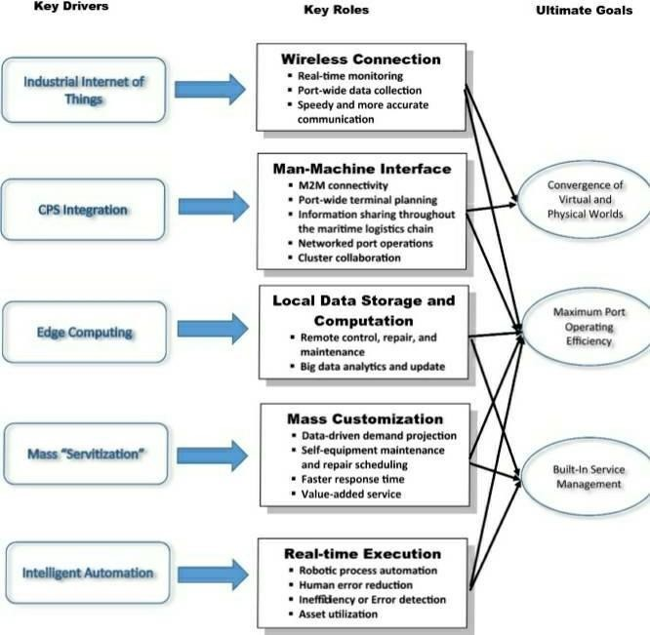 Team id : :PNT2022TMID03743

Scanned by TapScanner

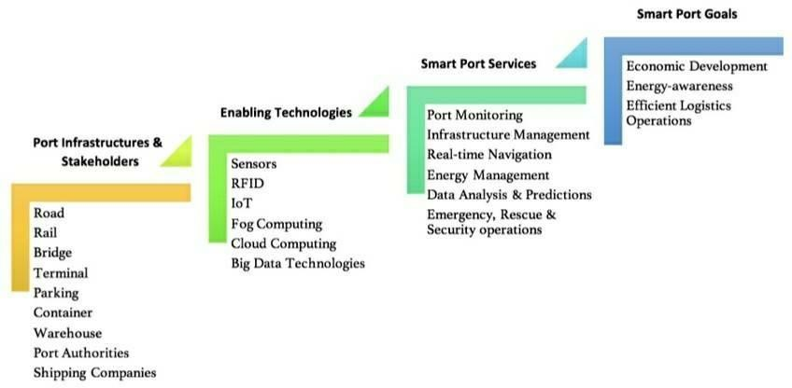

Scanned by TapScanner